

Draw It or Lose It

# **CS 230 Project Software Design Template**

Version 1.0

## Table of Contents

**CS 230 Project Software Design Template**1

**Table of Contents**2

**Document Revision History**2

**Executive Summary**3

**Design Constraints**3

**System Architecture View**3

**Domain Model**3

**Evaluation**3

**Recommendations**5

## Document Revision History

| Version | Date | Author | Comments |
| --- | --- | --- | --- |
| 1.0 | <mm/dd/yy> | <Your-Name> | <Brief description of changes in this revision> |

**Instructions**

Fill in all bracketed information on page one (the cover page), in the Document Revision History table, and below each header. Under each header, remove the bracketed prompt and write your own paragraph response covering the indicated information.

## Executive Summary

The world has faced difficulties in designing Draw It or Lose It games that can be played on a variety of devices. One of the most prevalent tasks was for participants to create pictures on an easel to assist team members in guessing the problem. As a result, the game was delayed, and the game was less enjoyable. Another issue is that there has been a sharp increase in demand for creative technology solutions, with people requesting new games that cater to various situations. Creative Technology Solutions (CTS) has recently taken on a new customer, The Gaming Room, as a result of the unexpected increase in demand for mobile application and web-based games. Draw It or Lose It is a game that can be played on a variety of platforms, thanks to the efforts of Creative Technology Solutions. Based on their current game, Draw It or Lose It, which is exclusively available as an Android app, The Gaming Room will develop a web-based game that will serve numerous platforms. Instead of a player sketching images on an easel, the program will display images from a big library of stock drawings as hints.

## Design Constraints

When designing an application, the design step is crucial. There are a few design restrictions to consider while designing web-based software. ESS diagrams, UML diagrams, and class diagrams are examples of these limitations. All of these examples are non-functional features that aid the software developer in visualizing the program that is required. They give the developer with the necessary programming tools, as well as technical requirements and other critical customer requirements. These restrictions also include the primary actors, actions, artifacts, classes, and roles, which provides for a better understanding and documentation of the software that has been produced.

## System Architecture View

Please note: There is nothing required here for these projects, but this section serves as a reminder that describing the system and subsystem architecture present in the application, including physical components or tiers, may be required for other projects. A logical topology of the communication and storage aspects is also necessary to understand the overall architecture and should be provided.

## Domain Model

The programDriver, SingletonTester, Entity, GameService, Game, Team, and Player classes are shown in the UML diagram below. The entity class serves as a parent interface for the four child classes. GameService, Game, Team, and Player have an association connection in which each entity is dependent on the other. As illustrated below, the singlectonTester class derives from the programDriver class, which is the main class. As previously said, inheritance is the most important object-oriented programming paradigm used in this UML diagram. It has given the singletonTester class the ability to conduct activities and responsibilities that the main class has inherited.

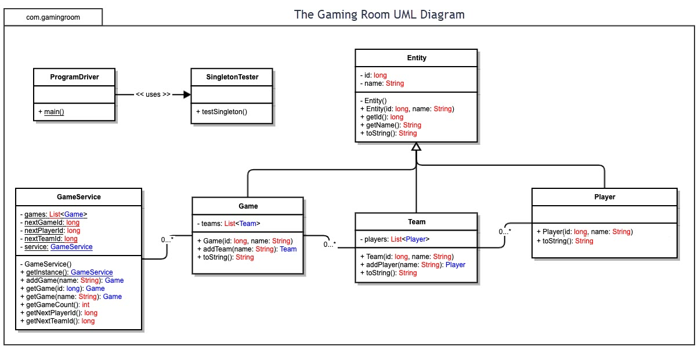

## Evaluation

Using your experience to evaluate the characteristics, advantages, and weaknesses of each operating platform (Linux, Mac, and Windows) as well as mobile devices, consider the requirements outlined below and articulate your findings for each. As you complete the table, keep in mind your client’s requirements and look at the situation holistically, as it all has to work together.

In each cell, remove the bracketed prompt and write your own paragraph response covering the indicated information.

| **Development Requirements** | **Mac** | **Linux** | **Windows** | **Mobile Devices** |
| --- | --- | --- | --- | --- |
| **Server Side** | A good graphical user interface that is simple to use. Accessibility and server settings are simple on the Mac. | The platform is difficult to navigate. Linux, like Mac, provides a command shell for easy server configuration and access. Cost friendly. | Windows servers, like Mac servers, are costly. The user interface is simple and intuitive. Developers have a plethora of software possibilities. Prompt for commands. | The characteristics of mobile devices differ from one user to the next; they are inexpensive. Android, iOS, and Windows Phone. Challenges in developing a game that is compatible with the majority of (if not all) mobile platforms. |
| **Client Side** | The average amount of time is required by Mac users. To traverse OS, you'll require precise skills. For users, this is an expensive alternative. | To support Linux systems, Linux users must devote as much time and expertise as possible. Linux users pay the bare minimum. To utilize this operating system, you must be familiar with Linux. | It does not take a long time for a user to learn how to support a Windows setup. The cost is higher than that of Linux systems. | To support mobile devices, users must devote a significant amount of time and effort. Applications designed on other platforms are difficult to run on mobile platforms. |
| **Development Tools** | JavaScript, HTML, CSS, Python, and more IDEs are available on Mac systems. Visual Studio, Eclipse, and online development tools are among the tools available on Mac platforms. | Java, Python, Ruby on Rails, HTML, and more IDEs are available on Linux platforms. Github, Repl.it, nodejs, Visual Studio, and other development tools are available for these platforms. | Python, C++ (as well as other C-like languages), HTML, and other languages are used in Windows OS. Eclipse, command prompt, and Repl.it are among the developer tools available (several of which are also available for other operating systems). | HTML, php, C++, Python, and other programming languages are available. Github, Visual Studio, the command line, Repl.it, and more programming tools are available. |

## Recommendations

Analyze the characteristics of and techniques specific to various systems architectures and make a recommendation to The Gaming Room. Specifically, address the following:

1. **Operating Platform**: The Windows server operating system is suggested for the Gaming Room's "Draw It or Lose It" application for expansion and the best outcomes. Windows server OS protects the PCs' reliability using a protected and supervisor mode. This aids in meeting the client's unique demands for computers connected to that network. This feature ensures that both the machines and the users function at their best. Web server, file server, application server, mail server, database server, print server, and other server roles are all supported by the Windows server OS. The Windows server operating system is designed to run on server hardware.
2. **Operating Systems Architectures**: Memory and file management are two concepts included in the Windows server operating system architectures that allow the user to control and coordinate the computer's memory to best suit their specific needs, such as allocating bits of memory to different programs and/or freeing space when it is no longer needed for later use. Windows server enables excellent application performance on computers with many processors when multi-processor scheduling is used. From a ready state to a running state of process, multi-processor scheduling assigns a particular amount of the processors' power to different tasks. PowerShell configuration is one of these systems that enables for regular maintenance across a company's machines/computers.
3. **Storage Management**: For storage management, Windows Server allows users to move portions of data to solid state storage on a regular basis, freeing up more space for their needs. This guarantees that the machines have enough storage space to edit and save data to the system without running out. Users can also view and write company files on personal and work-related devices by copying them to data center servers.
4. **Memory Management**: Random access memory, physical and virtual address space, and memory management options are all available with the Windows server OS, allowing for memory sizes ranging from two to four gigabytes. The supported pagefile allows the system to shift virtual address space pages to the system's hard drive, freeing up the random-access memory frame for other purposes.
5. **Distributed Systems and Networks**: In distributed systems, using networking support is an excellent approach to implement and use software. Distributed systems and networks have the advantage of allowing multiple workstations to communicate with each other and with different processors. Another significant characteristic of distributed systems and networks is the ability for users to communicate with various servers, such as web servers, data servers, and so on. When computers are connected to a network, tasks are distributed and processed between the user and the server, resulting in increased efficiency.
6. **Security**: The security layers provided help to prevent data or sensitive information breaches; in addition, this feature stops destructive attacks while boosting overall security capabilities. Shielded virtual machines are another feature of the Windows Server OS that allows host administrators/managers to prevent unwanted access to protected data. Windows Defender Application Control ensures that you have complete control over which programs run on your computer. This feature does not necessitate the installation of any additional software or hardware. Memory corruption attacks are also protected by default for Windows Server OS users. Windows Defender, which detects and prevents known malware, is also included with Windows Server. The advanced threat analytics tool searches Active Directory network traffic as well as SIEM data for potential threats and alerts the user.